Project: MSS60

**Chapter: 1.05**

**Module:** **Density correction in**

**EVT Moment Realization  
 Function: Density Correction**

**Authorization**

**Author (EA-E-2) Schlüter Date**  **03.05.2004**

**Editor (MSS60) Schmeier Date**  **21.12.2004**

**Approved (MSS60) Date**

**Approved (EA-E-2) Date**

**Changes: S380**

|  |  |  |
| --- | --- | --- |
| **Version** | **Date** | **Comment** |
| S370 | 30.4.2004 | 1st version as a separate module;  Replacement of existing sizes in the EVT Moment Realization module |
| S370 | 11.05.2004 | Delivery status  Open points:   * Lists for operating modes |
| S370 | 04.07.2004 | Delivery stand miniteam |
| S380 | 21.12.2004 | ks: Documentation of the implementation |

**Table**

1 Functional description 3

1.1 Physical background 3

1.2 Implementation 4

1.3 Function diagram 5

1.4 Application Notes 7

2 Data of the module 8

2.1 Variables 8

2.2 Parameters 9

2.3 Characteristics 11

2.4 Characteristics 11

3 Initial condition 12

3.1 Parameters 12

3.2 Characteristics 12

3.3 Characteristics 13

# Description

The control module Density Correction DKR contains control functions that compensate for the influence of a changed intake air condition. However, the intake pressure and ‑temperature are taken into account differently in the calculation. Compensation prevents a changed intake air condition from altering fresh air filling, residual gas content, cargo movement and, as a result, a change in the indexed work at the corresponding operating point.

Operating heights between -300 and +3000 m above sea level. pressure changes between +10% and -30% compared to a reference pressure of 960 mbar. For a reference temperature of 293 K, temperature changes of approx. +-10% occur in the relevant operating range.

The inflow behaviour, which is particularly crucial for fresh air filling, is primarily determined by the air condition in the suction tube. Therefore, the average suction tube pressure is used as the input factor for the calculation of compensatory measures.

The method realized here is a pure correction of the inlet closing control edge with the aim to adapt the fresh air filling to the applied value under reference conditions. The heating of the gas before re-released at late entry close is not explicitly taken into account. Assuming that the outflow process is primarily influenced by combustion, i.e. the indexed work, and less by the ambient state, the residual gas mass in the cylinder is not corrected. The influence of the charge movement is neglected.

The two calculation methods for the inlet lock correction ⎯based on the cylinder volume at inlet closing or the opening time of the inlet valve as well as the subsequent limitation of the ⎯corrected inlet lock control edge are described in more detail below.

## Physical background

The inlet closecorrection uses two parallel calculation methods: With the focus on partial load operation with full stroke of the valves, i.e. for operating points in which the fresh air filling is limited by the cylinder volume, the cylinder volume is evaluated at inlet closing. Assuming that the gas density in the cylinder at this time is proportional to the ambient state, the inlet closes the control edge is shifted so that the product of density and cylinder volume at inlet closure is equal to the applied reference state. With the cylinder volume *VES* as a geometric function of the inlet lock crank angle and the relative air density in the suction tube *rf_pt_korr_dichte:*

*VES,korr* = rf_pt_korr_dichte *VES,ref* =

At early inlet closing, a reduced density leads to a larger cylinder volume, i.e. to later inlet closes.

This correction corresponds to the correction function up to ECU level R 360.

In case of late inlet closing and reduced density, the necessary larger cylinder volume is realized by an earlier inlet lock. The cylinder volume as a function of the crank angle is symmetrical to the lower dead point at 540°. To extend the application possibilities, however, the inlet closes control edges to late inlet closes not [with ES :=1080 - ES] into the area of the Early Inlet Lock. Instead, the cylinder volume function is stored separately for this area.

With the focus on Minihub, i.e. for operating points in which the fresh air filling is determined by the inflow behavior of the inlet valves, the opening time of the inlet valve is evaluated. For operating modes with early inlet closing, this is the distance between inlet opens and inlet closes. For operating modes with late inlet Opens instead of inlet Opens the beginning of the re-displacement phase is relevant; this time is approximately the lower dead point. With the relative inlet mass current *rf_pt_korr_drossel* follows for the opening time of the inlet valve:

*ESkorr*  *- EO* = ( *ESref* - *EO* ) *rf_pt_korr_drossel*

The throttle characteristic or a laminar-turbulent approach for the inlet mass flow can be stored in two characteristic curves for the dependence on pressure and temperature:

*rf_pt_korr_drossel*  =

For operating points with high speeds or loads, a weighted average of both correction models is used. For the weighting of the opening time-based correction, the specific load per cylinder and inlet valve is used as the characteristic field input.

Before calculating the volume-related inlet lock correction, the inlet lock control edge can be moved compared to the calculation of the cylinder volume. This allows dynamic effects (pressure waves, resonances) to be taken into account. As an alternative to the proportional weighting of the opening-time-based correction, this intervention can also take into account the inflow pressure losses at high loads and speeds.

After calculation of the corrected inlet lock control edge this is limited to the physically reasonable range: Depending on the operating mode Early or Late Inlet Closing, the limits here are the dead points of the piston movement or the full load control times.

## Implementation

In the signal flow, the module Density Correction transfers the inlet schliesset control edge *formed* in the module EVT moment realization from the base characteristic fields or the application intervention es_bas into a corrected inlet Closes control edge *drk_es_aw* (previous name: *es_aw*).

For external calculations, the relative density *rf_pt_korr* is also provided. This is set equal to the relative density for the volume-related inlet closing correction *drk_rf_pt_korr_dichte*. Relative density rf_pt_korr is also *rf_pt_korr* provided for external calculations. The relative flow *drk_rf_pt_korr_drossel* is also used externally. All other variables calculated in this module are internal.

With the exception of the characteristic KL_STKN_ES_VL, all parameters in the module are internal.

Note on implementation:

The function is very runtime-intensive, as large parts of it (with several interpolations) are expected in the segment grid. If the MSS60 is operated on an 8-cylinder engine, it is advisable to switch off the density correction (K_DKR_FUNC_MODE = DKRoff), otherwise the performance is not sufficient for higher speeds. You may need to rethink the design of the function in the future to get by with less computing time or computational frequency.

## Function diagram

Module Density Correction (dkr)

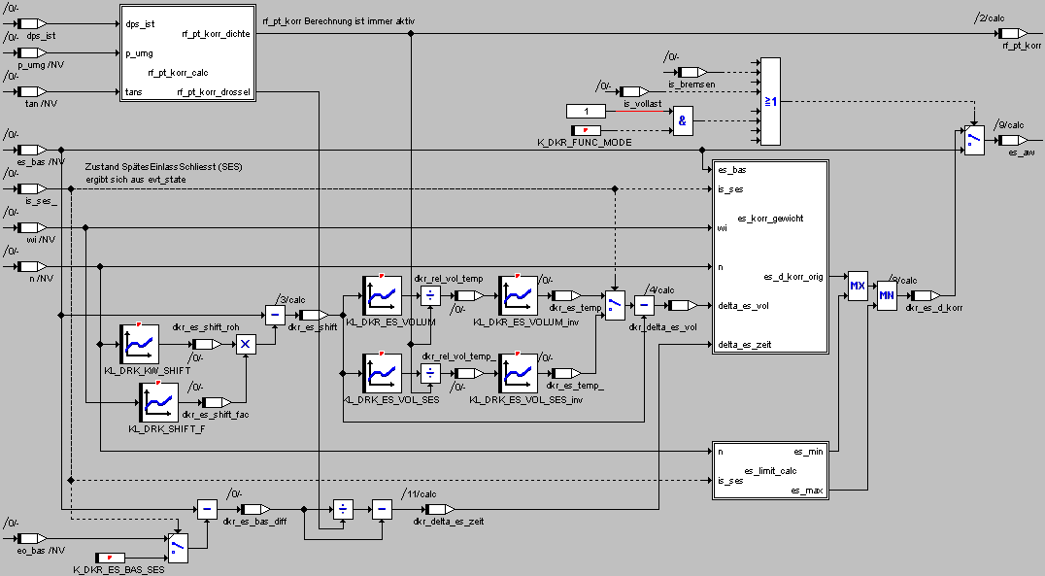

Submodule dkr_rf_pt_korr_calc (calculated in the background)

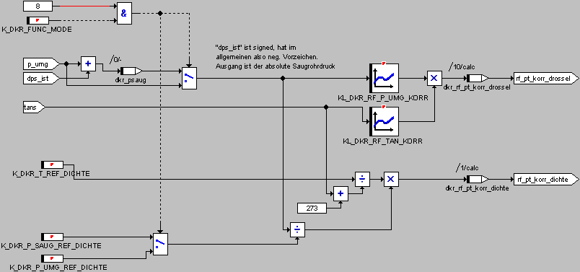

Submodule dkr_es_limit_calc

(Deviating from the structogram, the limit values K_DKR_ES_MIN / K_DKR_ES_MAX are used in "dkr_es_limit_calc".)

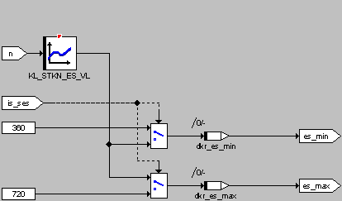

Submodule dkr_es_korr_gewichtet

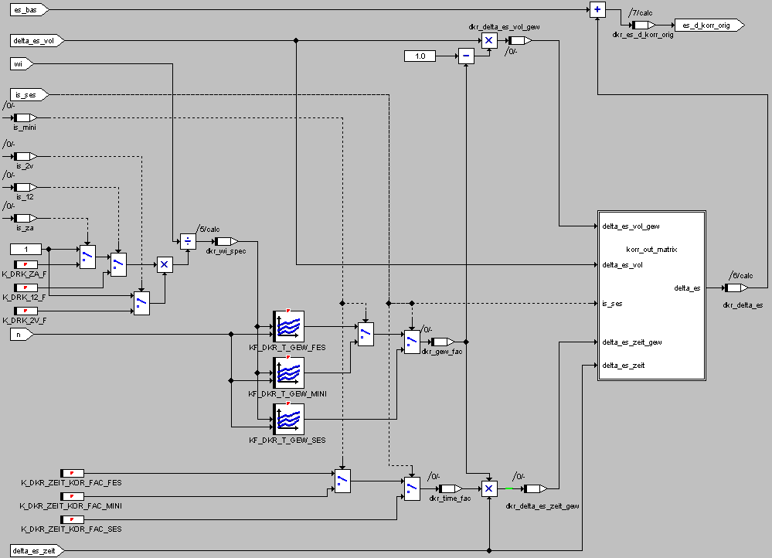

Submodule dkr_korr_out_matrix

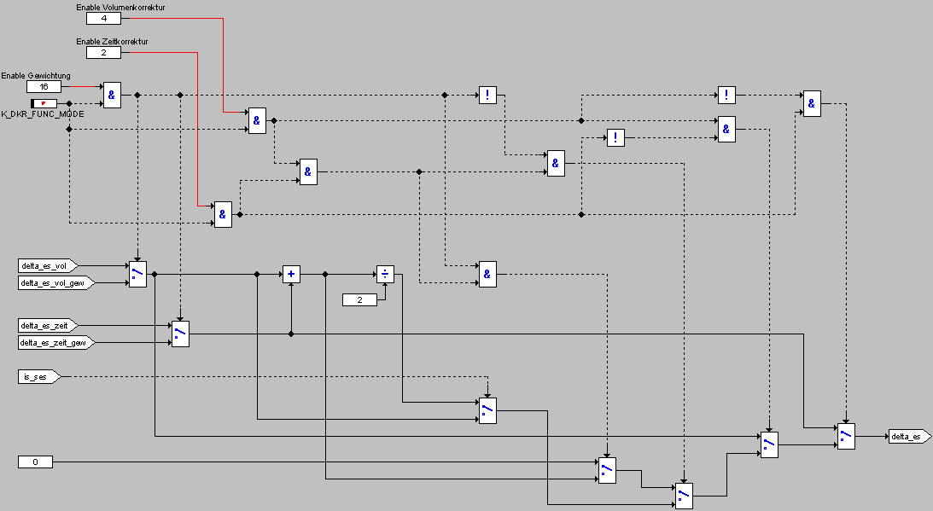

## Application instructions

The reference ambient state is 960 mbar at 20°C. With a suction tube vacuum of 50 mbar in most operating points, the reference suction pipe condition has an air pressure of 910 mbar.

# Data of the module

The calculation of the function is done segment-synchronously in the slave.

rf_pt_korr calculations are performed in the background

|  |  |  |  |  |  |  |  |
| --- | --- | --- | --- | --- | --- | --- | --- |
|  | Angle | background | 1ms | 10ms | 20ms | 100ms | 1s |
| Task | Dkr | dkr_rf_pt_korr_calc |  |  |  |  |  |

## Variables

The module does not contain static variables, all sizes are global.

|  |  |  |  |  |  |  |
| --- | --- | --- | --- | --- | --- | --- |
| Variable  [Output] | Initialization | Unit | Area  (physical.) | Quant. | Impl. | Page |
| dkr_es_aw |  | ° | 0 - 720 | 0,1 | Word |  |
| Crank Angle Inlet Closes Output Density Correction | | | | | |
| Global output size | | | | | |
| rf_pt_korr | 1 | - | 0 - 2,5 | x/128 | Byte |  |
| rf_pt_korr set to external functions as rf_pt_korr_dichte | | | | | |
| Calculated from: p_umg, dps_ist, tan | | | | | |
| dkr_rf_pt_korr_drossel | 1 | - | 0 - 2,5 | x/128 | Byte |  |
| rf_pt_korr (relative mass flow) for density correction via opening time inlet valve | | | | | |
| Calculated from: p_umg, dps_ist, tan | | | | | |

|  |  |  |  |  |  |  |
| --- | --- | --- | --- | --- | --- | --- |
| Variable  [Local] | Initialization | Unit | Area  (physical.) | Quant. | Impl. | Page |
| dkr_rf_pt_korr_dichte | 1 | - | 0 - 2,5 | x/128 | Byte |  |
| rf_pt_korr (relative density) for density correction over cylinder volume | | | | | |
| dkr_delta_es_vol | 0 | ° | -180 - 180 | 0,1 | Word |  |
| Inlet Closes crank angle correction from cylinder volume | | | | | |
| dkr_delta_es_zeit | 0 | ° | -180 - 180 | 0,1 | Word |  |
| Inlet Closes crank angle correction from opening time inlet valve | | | | | |
| dkr_delta_es | 0 | ° | -180 - 180 | 0,1 | Word |  |
| Inlet Closes crank angle correction | | | | | |
| dkr_es_d_korr_orig |  | ° | 0 - 720 | 0,1 | Word |  |
| Crank angle inlet Closes after density correction without min/max limit | | | | | |
| dkr_es_d_korr |  | ° | 0 - 720 | 0,1 | Word |  |
| Crank angle inlet lock calculated in density correction (return value of "dkr()") | | | | | |
| dkr_es_min |  | ° | 0 - 720 | 0,1 | Word |  |
| Minimum value limit | | | | | |
| dkr_es_max |  | ° | 0 - 720 | 0,1 | Word |  |
| Maximum value limit | | | | | |
| dkr_es_shift |  | ° | 0 - 720 | 0,1 | Word |  |
| Work value in "dkr()" | | | | | |
| dkr_wi_spec |  | kJ/l | like "wi" |  | Word |  |
| Work value in "dkr_es_korr_gewichtet()" | | | | | |
| dkr_gew_fac |  |  | 0 - 1 | 0,05 | Byte |  |
| Work value in "dkr_es_korr_gewichtet()" | | | | | |
| dkr_time_fac |  |  | 0 – 12,7 | 0,05 | Byte |  |
| Work value in "dkr_es_korr_gewichtet()" | | | | | |
| dkr_delta_es_zeit_gew | 0 | ° | -180 - 180 | 0,1 | Word |  |
| Work value in "dkr_es_korr_gewichtet()" | | | | | |
| dkr_delta_es_vol_gew | 0 | ° | -180 - 180 | 0,1 | Word |  |
| Work value in "dkr_es_korr_gewichtet()" | | | | | |

|  |  |  |  |  |  |  |
| --- | --- | --- | --- | --- | --- | --- |
| Variable  [Input] | Source | Unit | Area  (physical.) | Quant. | Impl. | Page |
| eo_bas | EVT moments real. | Deg |  |  |  |  |
| Control edge inlet Opens | | | | | |
| es_bas | EVT moments real. | Deg |  |  |  |  |
| Base control edge entrance closes | | | | | |
| evt_state | EVT moments real. | - |  |  |  |  |
| Mode | | | | | |
| Tan |  | ℃ |  |  |  |  |
| Intake air temperature | | | | | |
| p_umg |  | Mbar |  |  |  |  |
| Ambient | | | | | |
| Wi |  | kJ/l |  |  |  |  |
| indexed work | | | | | |
| N |  | Rin |  |  |  |  |
| Speed | | | | | |
| dps_ist |  | Mbar |  |  |  |  |
| Suction tube underpressure (averaged) | | | | | |

## Parameter

|  |  |  |  |  |  |  |
| --- | --- | --- | --- | --- | --- | --- |
| Application size | Standard value | Unit | Area  (physical.) | Quant. | Impl. | Page |
| K_DKR_FUNC_MODE | DKR OFF | - | 0x00: DKR=0 (ineffective)  0x07: DKR[t/V/ups/Gew]=1  0x13: V/Gew=0  0x15: t/Gew=0  0x17: Gew=0  0x03: V=0  0x05: t=0  0x0F: ups=0  0x1B: V/ups/Gew=0  0x1D: t/ups/Gew=0  0x1F: ups/Gew=0  0x0B: V/ups=0  0x0D: t/ups=0  0x80: DKR OFF (disabled) | - | Byte |  |
| Switch: Inlet Closes intervention of the density correction disable/switch | | | | | |
| K_DKR_ES_BAS_SES | 540 | ° | 500 - 755 | 1 | Byte |  |
| Crank angle: Start of outflow at SES | | | | | |
| K_DKR_ES_MIN | 400 | ° | 500 - 755 | 1 | Byte |  |
| Limit value in "dkr_es_limit_calc" (equivalent to structogram) | | | | | |
| K_DKR_ES_MAX | 660 | ° | 500 - 755 | 1 | Byte |  |
| Limit value in "dkr_es_limit_calc" (equivalent to structogram) | | | | | |
| K_DKR_P_REF_DICHTE | 910 | Mbar | 850 - 1105 | 1 | Byte |  |
| Reference suction tube pressure for air condition | | | | | |
|  |  |  |  |  |  |  |
|  | | | | | |
| K_DKR_ZEIT_KOR_FAC_FES | 1 | - | 0 - 12,7 | 0,05 | Byte |  |
| Additional weighting factor: Opening-time-related inlet closes correction for FES | | | | | |
| K_DKR_ZEIT_KOR_FAC_Mini | 1 | - | 0 - 12,7 | 0,05 | Byte |  |
| Additional weighting factor: Opening-time-related inlet closes correction for ministroke | | | | | |
| K_DKR_ZEIT_KOR_FAC_SES | 1 | - | 0 - 12,7 | 0,05 | Byte |  |
| Additional weighting factor: Opening-time-related inlet closes correction for SES | | | | | |
| K_DKR_T_REF_DICHTE | 293 | K | 270 - 525 | 1 | Byte |  |
| Reference temperature for air condition | | | | | |
| K_DRK_ZA_F | 2 | - | 0 - 5 | 0,02 | Byte |  |
| Multiplication factor for cylinder load during cylinder shutdown | | | | | |
| K_DRK_2V_F | 2 | - | 0 - 5 | 0,02 | Byte |  |
| Multiplication factor for cylinder load at 2V operation | | | | | |
| K_DRK_12_F | 3 | - | 0 - 5 | 0,02 | Byte |  |
| Multiplication factor for cylinder load at 12-stroke operation | | | | | |

## Characteristics

|  |  |  |  |  |  |  |
| --- | --- | --- | --- | --- | --- | --- |
| Application size | Support points | Unit | Area | Quant. | Impl. | Page |
| KL_DKR_ES_VOLUM | 8 x KW | ° | 465 - 720 | 1 | 16 * byte |  |
|  | - | 0 – 2 (3) |  | 16* byte |  |
| Cylinder volume = f( crank angle ); Characteristic must be invertible | | | | | |
| KL_DKR_ES_VOL_SES | 8 x KW | ° | 465 - 720 | 1 | 16 * byte |  |
|  | - | 0 - 1 |  | 16 * byte |  |
| Cylinder volume = f( crank angle ) for SES; Characteristic must be invertible | | | | | |
| KL_DKR_RF_P_UMG_KORR | 8 x p | Mbar | 600 - 1110 | 2 | 8 * byte |  |
|  | - | 0 - 2,5 | x/128 | 8 * byte |  |
| KL_DKR_ES_VOLUM inversely deposited | | | | | |
| KL_DKR_RF_TAN_KORR | 8 x t | ℃ | -40 - 85 | 1 | 8 * byte |  |
|  | - | 0 - 2,5 | x/128 | 8 * byte |  |
| KL_DKR_ES_VOLUM inversely deposited | | | | | |
| KL_DKR_KW_SHIFT | 32 x KW | Rin | 0 - 7500 | 50 | 32 * byte |  |
|  | Deg | -30 - 120 | x/128 | 32 * byte |  |
| Crank angle shift Inlet Closes to cylinder volume calculation | | | | | |
| KL_DKR_KW_SHIFT_F | 8 x wi | kJ/l | 0 - 1,5 | 0,01 | 8 * byte |  |
|  | - | 0 - 2,5 | 0,01 | 8 * byte |  |
| Load-dependent weighting of the crank angle shift | | | | | |
| KL_STKN_ES_VL |  | Rin |  |  |  |  |
|  | Deg |  |  |  |  |
| Base control edge inlet closes bulk load (included from the load module) | | | | | |

## Kennfelder

|  |  |  |  |  |  |  |
| --- | --- | --- | --- | --- | --- | --- |
| Application size | Support points | Unit | Area | Quant. | Impl. | Page |
| KF_DKR_T_GEW_FES |  | Rin | 0 - 6500 |  | 8 * byte |  |
|  | kJ/l | 0 - 1,5 |  | 8 * byte |  |
|  | - | 0 - 1 | 0,05 | 8*8 * byte |  |
| Weighting factor for opening time-based density correction for FES | | | | | |
| KF_DKR_T_GEW_MINI |  | Rin | 0 - 6500 |  | 8 * byte |  |
|  | kJ/l | 0 - 1,5 |  | 8 * byte |  |
|  | - | 0 - 1 | 0,05 | 8*8 * byte |  |
| Weighting factor for opening time-based density correction for ministroke | | | | | |
| KF_DKR_T_GEW_SES |  | Rin | 0 - 6500 |  | 8 * byte |  |
|  | kJ/l | 0 - 1,5 |  | 8 * byte |  |
|  | - | 0 - 1 | 0,05 | 8*8 * byte |  |
| Weighting factor for opening time-based density correction for SES | | | | | |

# Initial condition

The following indicates an initial condition for all application values. For some parameters, values are also given to realize the functionality of the old density correction (R360): In this case, the opening time-based correction as well as the displacement between inlet lock crank angle and cylinder volume calculation are neutralized.

## Parameter

K_DKR_B_DRK_OFF0

K_DKR_ES_BAS_SES540 °

K_DKR_ES_MIN 400°

K_DKR_ES_MAX 660°

K_DKR_P_REF_DICHTE 910 mbar (= 960 - 50)

K_DKR_T_REF_DICHTE 293 K

K_DKR_ZEIT_KOR_FAC_FES 1 for Stand R360: 0

K_DKR_ZEIT_KOR_FAC_Mini 1 for Stand R360: 0

K_DKR_ZEIT_KOR_FAC_SES 1 for Stand R360: 0

K_DKR_ZA_F 2

K_DKR_2V_F 2

K_DKR_12_F 3

## Kennfelder

KF_DRK_T_GEW_FES: constant 0

KF_DRK_T_GEW_SES: constant 0

KF_DRK_T_GEW_MINI: constant 1

## Characteristics

**KL_DKR_ES_VOLUM**

Characteristic must be invertible

From 540 to 543 two support points with incline 1! Data analogous current status, linearextra polished

|  |  |  |  |  |  |  |  |  |
| --- | --- | --- | --- | --- | --- | --- | --- | --- |
| Kw | 360 | 370 | 390 | 420 | 460 | 500 | 540 | 720 |
| Output [ ] | 0,088 | 0,097 | 0,168 | 0,372 | 0,696 | 0,925 | 1 | 3 |

Bedfrom old software stand without DKR.

**KL_DKR_ES_VOL_SES**

Characteristic must be invertible; Data analogous current status, mirrored at 540°, linearextra extrapolated

|  |  |  |  |  |  |  |  |  |
| --- | --- | --- | --- | --- | --- | --- | --- | --- |
| Kw | 540 | 550 | 570 | 600 | 630 | 660 | 690 | 720 |
| Output [ ] | 1 | 0,991 | 0,920 | 0,761 | 0,469 | 0,260 | 0,130 | 0,088 |

Bedfrom old software stand without DKR.

**KL_DKR_RF_P_UMG_KORR**

|  |  |  |  |  |  |  |  |  |
| --- | --- | --- | --- | --- | --- | --- | --- | --- |
| P_UMG | 599 | 749 | 800 | 851 | 899 | 959 | 1040 | 1100 |
| Output [-] | 0,62 | 0,78 | 0,83 | 0,88 | 0,94 | 1 | 1,08 | 1,14 |

**KL_DKR_RF_TAN_KORR**

|  |  |  |  |  |  |  |  |  |
| --- | --- | --- | --- | --- | --- | --- | --- | --- |
| Tan | -40 | -20 | 0 | 20 | 40 | 60 | 80 | 100 |
| Output [Nm] | 1,26 | 1,16 | 1,07 | 1 | 0.94 | 0,88 | 0,82 | 0,73 |

**KL_DRK_KW_SHIFT**

Calculated as full load inlet close - 540° with limitation not negative.

If the full load is driven with a different DISA position, still modify values.

|  |  |  |  |  |  |  |  |
| --- | --- | --- | --- | --- | --- | --- | --- |
| N | 400 | 800 | 1200 | 1600 | 2000 | 2400 | 2800 |
| Output [ ] | 0 | 0 | 0 | 12 | 7 | 13 | 20 |

|  |  |  |  |  |  |  |  |  |
| --- | --- | --- | --- | --- | --- | --- | --- | --- |
| 3200 | 3600 | 4000 | 4400 | 4800 | 5200 | 5600 | 6000 | 6400 |
| 26 | 34 | 44 | 46 | 51 | 60 | 74 | 93 | 120 |

In order to realize status R360, this or the characteristic curve KL_DRK_KW_SHIFT_F must be set constant 0. Had to be reduced to 16 support points !

**KL_DRK_KW_SHIFT_F**

|  |  |  |  |  |  |  |  |  |
| --- | --- | --- | --- | --- | --- | --- | --- | --- |
| Wi | 0 | 0,2 | 0,4 | 0,6 | 0,8 | 0,9 | 1 | 1,4 |
| Output [ ] | 0 | 0,2 | 0,4 | 0,6 | 0,8 | 0,9 | 1 | 1 |